OudhTrade
Database Design
Module 1 — Platform Foundation · M01-5
Document details
Company | MRIDA INFRA AND PLANTATIONS LLP
Product | OudhTrade — oudhtrade.com
Document | M01-5 Database Design
Module | M01 Platform Foundation (release R1)
Readers | Backend developers, DBA, tech lead
Related documents | PRD (PRD-FND, PRD-CMP) · HLD · other M01 documents
Owner | Tech lead
Decision owner | T. Satish Reddy, CEO & Founder
Status | Draft for review — 24 September 2026
Classification | Confidential — for partners and the OudhTrade team

Contents
1. Overview 3
1.1 Standard columns 3
1.2 How to read the table diagrams 4
2. Files and Media 5
2.1 files 5
2.2 file_variants 6
2.3 video_assets 6
2.4 image_blocklist 7
3. Units 7
3.1 units 7
3.2 area_unit_factors 8
4. Languages and Preferences 8
4.1 translations 8
4.2 user_preferences 9
4.3 trade_terms 9
5. Countries and Exchange Rates 10
5.1 countries 10
5.2 country_regions 11
5.3 country_districts 11
5.4 fx_rates 11
6. Addresses 12
6.1 url_slugs 12
6.2 url_redirects 12
7. Audit Log 12
7.1 audit_log 12
8. Configuration, Switches and Rate Limits 14
8.1 config_versions / config_entries 14
8.2 feature_flags 15
8.3 rate_limit_policies 16
8.4 rate_limit_blocks 16
8.5 tag_groups 16
8.6 tags 17
9. Events and Jobs 17
9.1 outbox_events 17
9.2 processed_events 18
9.3 jobs / schedules 18
9.4 audit_verify_runs 18
10. Retention, Legal Hold and Consent 19
10.1 retention_policies 19
10.2 legal_holds 19
10.3 cookie_consents 19
10.4 retention_run_results 20
11. Links to Other Modules 20
11.1 Shared link columns 21
12. Rules 22
13. AI Gateway, API Safety, Names and Calendar 22
13.1 ai_requests 22
13.2 ai_budgets 23
13.3 idempotency_keys 23
13.4 reserved_names 24
13.5 business_holidays 24
14. Indexes and Volumes 25
14.1 Photo fingerprint search 26

1. Overview
Module 1 has 37 tables in PostgreSQL in a schema named `platform`. Other modules refer to them only by ID through Module 1 interfaces. Tables follow the Master Database Design standards (naming, IDs, data types). IDs are UUID version 7 (time-ordered), except high-volume logs. Money is never stored in Module 1 tables; the only amounts are AI costs and budgets (Section 13).

1.1 Standard columns
Columns | On which Module 1 tables
id | Every main table: uuid version 7 (exceptions: bigint identity for the append-only logs and natural keys for reference data, below)
created_at / created_by | All tables (append-only tables — audit_log, outbox_events, processed_events, fx_rates, cookie_consents, ai_requests — have created_at only, or their own time column)
updated_at / updated_by | All tables whose rows change
row_version | Tables edited by staff or users: units, area_unit_factors, translations, user_preferences, trade_terms, countries, country_regions, country_districts, url_slugs, config_versions, feature_flags, rate_limit_policies, retention_policies, legal_holds, reserved_names, business_holidays, ai_budgets, tag_groups, tags
anonymised_at | Tables with personal data about a person: user_preferences, cookie_consents (set when the account is closed and anonymised)
active | Reference data that is retired, never deleted

Standard columns are not repeated in the tables below. `created_by` and `updated_by` hold the staff or account ID of the person who made the change; they are null for system jobs (Master Database Design, Section 4.3). `config_versions.id` is a running number (version 1, 2, 3 …) because staff refer to settings by version — an allowed exception to the UUID rule.
Natural keys. Some tables use their natural code as the primary key instead of a UUID: units.code, countries.code, country_regions.code, country_districts.code, area_unit_factors, translations, fx_rates, feature_flags.name, rate_limit_policies, retention_policies.data_type, schedules.name, url_redirects.old_path, tag_groups.group_key and tags (group_key, tag_key). These are reference and lookup data that nothing else links to by a hidden ID, so they follow the reference-data exception of the Master Database Design (Sections 4.2 and 4.5). All other tables, including the five platform-service tables in Section 13, use `id uuid` (or bigint identity for append-only logs).
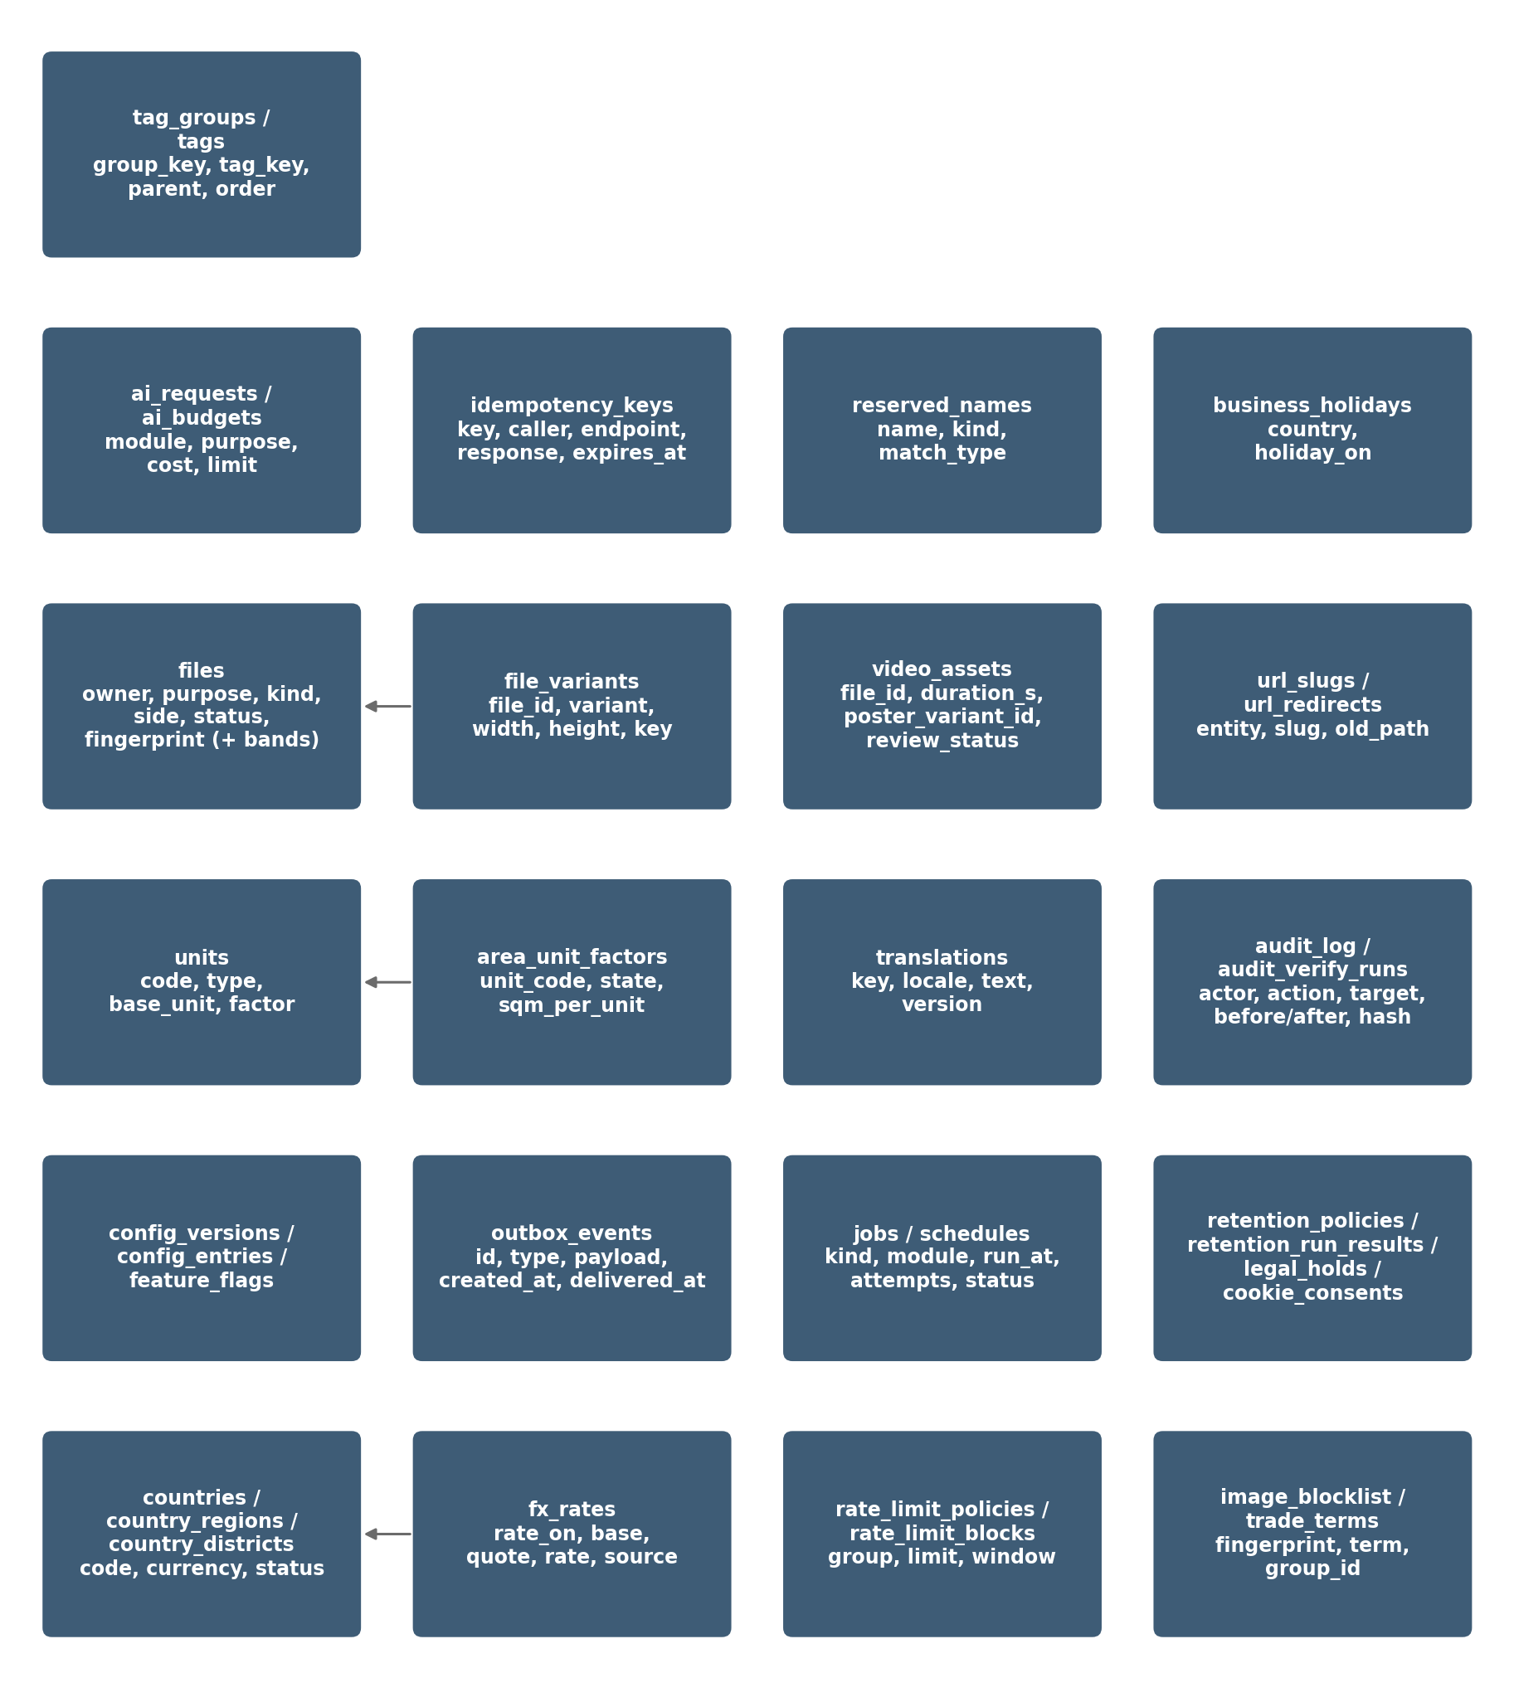
Figure 1 — Module 1 data model (overview)

1.2 How to read the table diagrams
The marks used in the table diagrams (PK, FK, ref, one / many, optional / required, dashed lines) are explained in the diagram key of the Master Database Design, Section 1.3. Diagrams show the main columns; the full column list is in each table below.

2. Files and Media
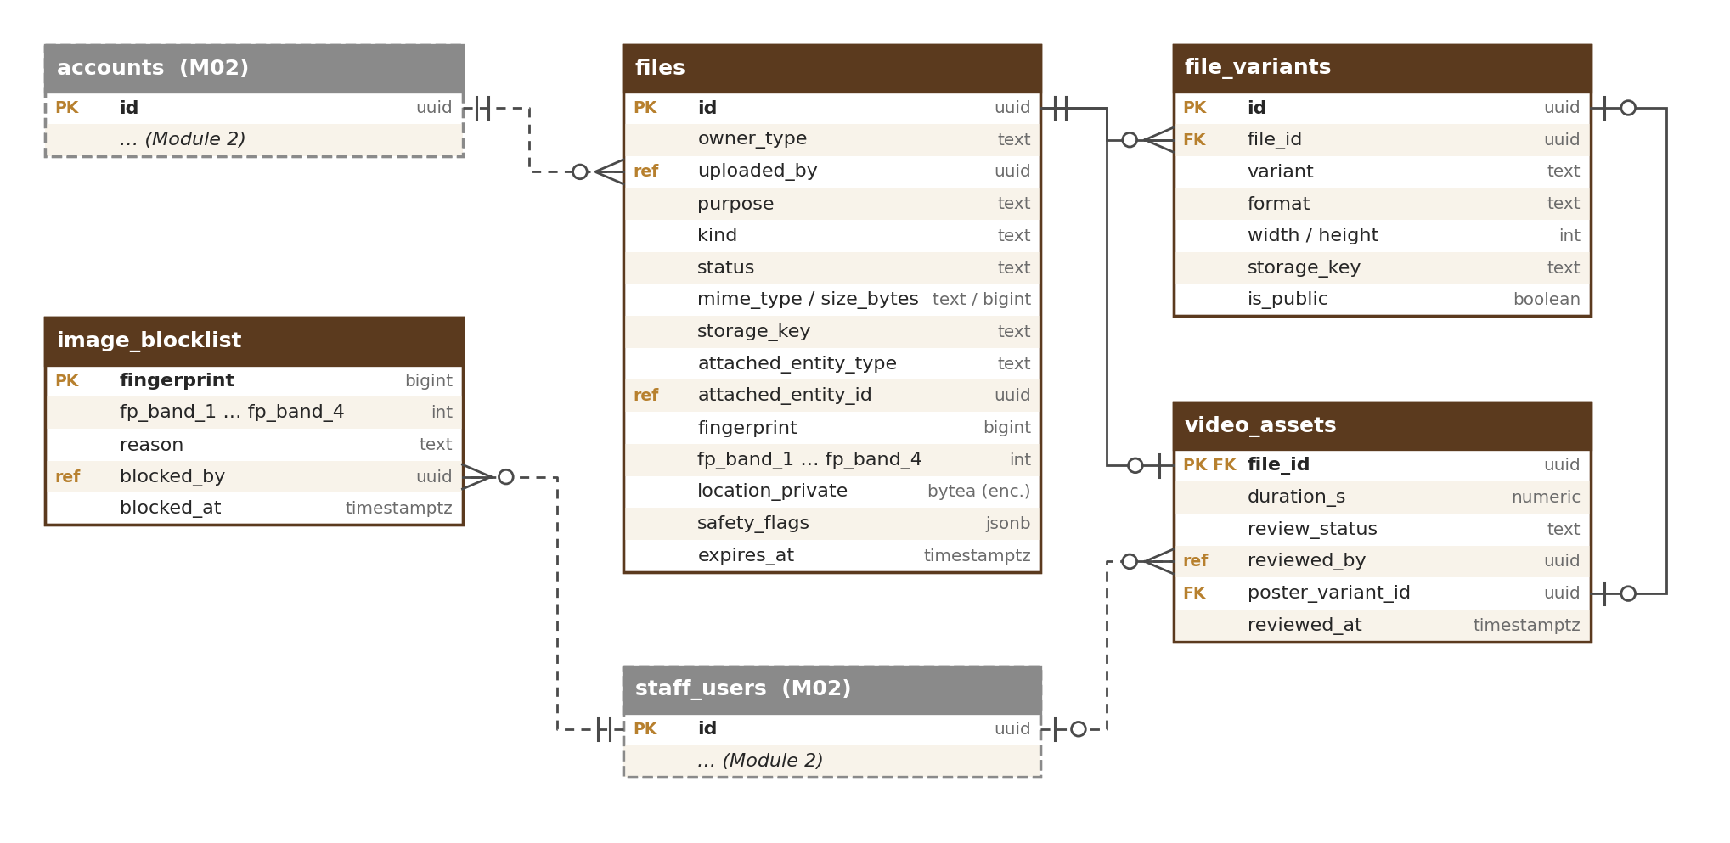
Figure 2 — Files and media tables

2.1 files
One row per uploaded file.
Column | Type | Notes
id | uuid PK
owner_type | text | account or staff (check)
uploaded_by | uuid (ref) | Who uploaded and owns the file: an account (owner_type = account) or a staff user (owner_type = staff); the only person who can get a signed link (FIL-009)
purpose | text | listing_photo, listing_video, location_photo, location_video (business location media, M03), farm_visit_photo (M03), verification_doc, verification_photo, origin_doc, origin_photo, chat_attachment, avatar, logo, cms_image…
side | text | Optional: front, back, selfie or page (for ID and document scans); set from the upload slot of the M03 / M06 form (POST /v1/files, parameter side)
kind | text | photo, document, video
original_name | text | Stored for display only
mime_type / size_bytes | text / bigint | Checked by file signature
status | text | pending_upload, uploaded, scanning, processing, held, in_review, ready, attached, expired, rejected_infected, rejected, failed, deleted (meaning of each state: M01-3 Section 2.1)
scan_result / scanned_at | text / timestamptz | clean / infected / error
storage_key | text | Private original object key
attached_entity_type / _id | text / uuid | Set when attached (e.g. listing). Shared link — see Section 11.1
quality_warning | text | small, blurred or null
has_watermark | boolean | Copied from the owner’s default (user_preferences.watermark_default) when the photo is uploaded
location_private | bytea (encrypted) | GPS from the original photo, encrypted by the application; kept only for the purposes farm_visit_photo, verification_doc, verification_photo, location_photo, origin_doc and origin_photo — null for all other purposes (removed at upload, FIL-022); visible only with photo_location.view; views audited
safety_flags | jsonb | Found text types: phone, email, upi, url, qr
fingerprint | bigint | Perceptual photo fingerprint (64-bit pHash)
duplicate_suspected | boolean | True when the photo matches another seller’s photo (FIL-024); the status stays ready or attached until M12 decides
fp_band_1 … fp_band_4 | int | The fingerprint cut into four 16-bit bands (values 0–65,535); each band indexed for similarity search (Section 14.1)
reject_reason | text | For rejected or failed
expires_at | timestamptz | Unconfirmed slot: 24 hours; unattached upload: 7 days

Photo order and the cover (first photo) of a listing are stored by the module that owns the listing, on its listing-photo link (M05, a position column); files has no order column.

2.2 file_variants
Processed versions of a photo or video.
Column | Type | Notes
id | uuid PK
file_id | uuid FK → files
variant | text | thumb, medium, large, blurred, web_720p, poster; blurred = public copy with faces blurred (farm-visit and business-location photos, FIL-028) from which the public sizes are made
blur_boxes | jsonb | Blurred variant only: face boxes found automatically and boxes added by staff on M03-AD-03
format | text | jpg, webp, mp4
width / height | int
storage_key / is_public | text / boolean | Public bucket only for approved photo and video variants

2.3 video_assets
Extra data for videos.
Column | Type | Notes
file_id | uuid PK, FK → files
duration_s | numeric(5,1) | ≤ 60 for a listing video, ≤ 45 for a business-location video (configurable)
review_status | text | in_review, approved, rejected
reviewed_by / reviewed_at | uuid / timestamptz | Moderator (Module 12)
poster_variant_id | uuid FK → file_variants | Cover image

2.4 image_blocklist
Photos removed by moderation that may not be uploaded again.
Column | Type | Notes
fingerprint | bigint PK
fp_band_1 … fp_band_4 | int | Same four bands as files, each indexed, so near copies are also found
reason | text | copied, stock, banned
blocked_by / blocked_at | uuid / timestamptz | Moderator (Module 12)

3. Units
Units are shown together with countries in the diagram in Section 5 (bigha, katha and lessa factors depend on the state). Both unit tables are managed in the units screen (M01-6 Section 12.13) or moved from staging by export / import, with the same approval.

3.1 units
Standard and local units (Admin-managed).
Column | Type | Notes
code | text PK | g, kg, quintal, tonne, tola_w, mithqal, seer, maund, ml, l, tola_oil, qtola_oil, piece, stick, packet, box, bottle, plant, tree, acre, hectare, sqm, bigha, katha, lessa
type | text | weight, volume, count, area
base_unit | text | g, ml, none, sqm
factor_to_base | numeric(18,6) | e.g. tola_w 11.66, mithqal 4.25, tola_oil 12; null for count and state-based area
is_state_based | boolean | true for bigha, katha, lessa
label_key | text | Translation key
is_helper_only | boolean | True for units used only on the helper line (e.g. tola, mithqal), never as the stored unit of a price
active / version | boolean / int | Retire, never delete

3.2 area_unit_factors
Factor per state for bigha, katha and lessa (state land-unit table, M01-2 UNT-009).
Column | Type | Notes
unit_code | text FK → units | bigha, katha, lessa
region_code | text FK → country_regions | ISO 3166-2, e.g. IN-AS (Assam)
sqm_per_unit | numeric(14,4) | Starting values for Assam and West Bengal in M01-2 UNT-009, e.g. IN-AS bigha 1,337.8038
source | text | State land record checked before the row was added (name and date); required
active | boolean | Retire, never delete
PK | (unit_code, region_code)

4. Languages and Preferences
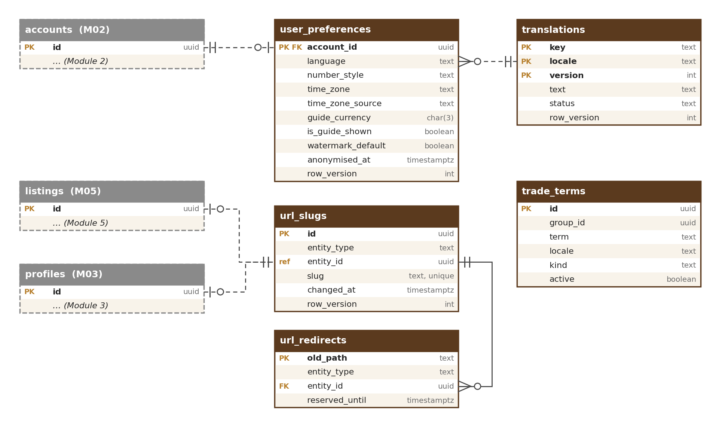
Figure 3 — Languages, preferences and page-address tables

4.1 translations
All user-facing text.
Column | Type | Notes
key | text | e.g. m01.s09.language.label (pattern: Cross-Module Standards Section 8; the key of each screen field is in the Screen–Field Map)
locale | text | en, ar, hi…
text | text | May contain placeholders {name}
version / status | int / text | draft, published
PK | (key, locale, version)

4.2 user_preferences
Display preferences per account.
Column | Type | Notes
account_id | uuid PK
language | text | default en
number_style | text | indian or international
time_zone | text | IANA name, e.g. Asia/Kolkata
time_zone_source | text | How the time zone was set: country, browser or user. M02 writes country or browser at sign-up; the Module 1 preferences page (PUT /v1/me/preferences) writes user; a zone chosen by the user is never overwritten by an automatic one
guide_currency / is_guide_shown | char(3) / boolean | Default from the Country table; viewer can change or switch off
watermark_default | boolean | Default for the “Add OudhTrade watermark to my photos” switch (false); remembered per account and copied to files.has_watermark on each new photo

4.3 trade_terms
Shared word list for names across languages and markets (filled by M04, used by M07).
Column | Type | Notes
id | uuid PK
group_id | uuid | Terms with the same meaning share a group (e.g. agarwood · oud · agar · gaharu · jinko · chen xiang)
term / locale | text / text | Term and its language
kind | text | product, grade, unit, origin
active | boolean | Retire, never delete

5. Countries and Exchange Rates
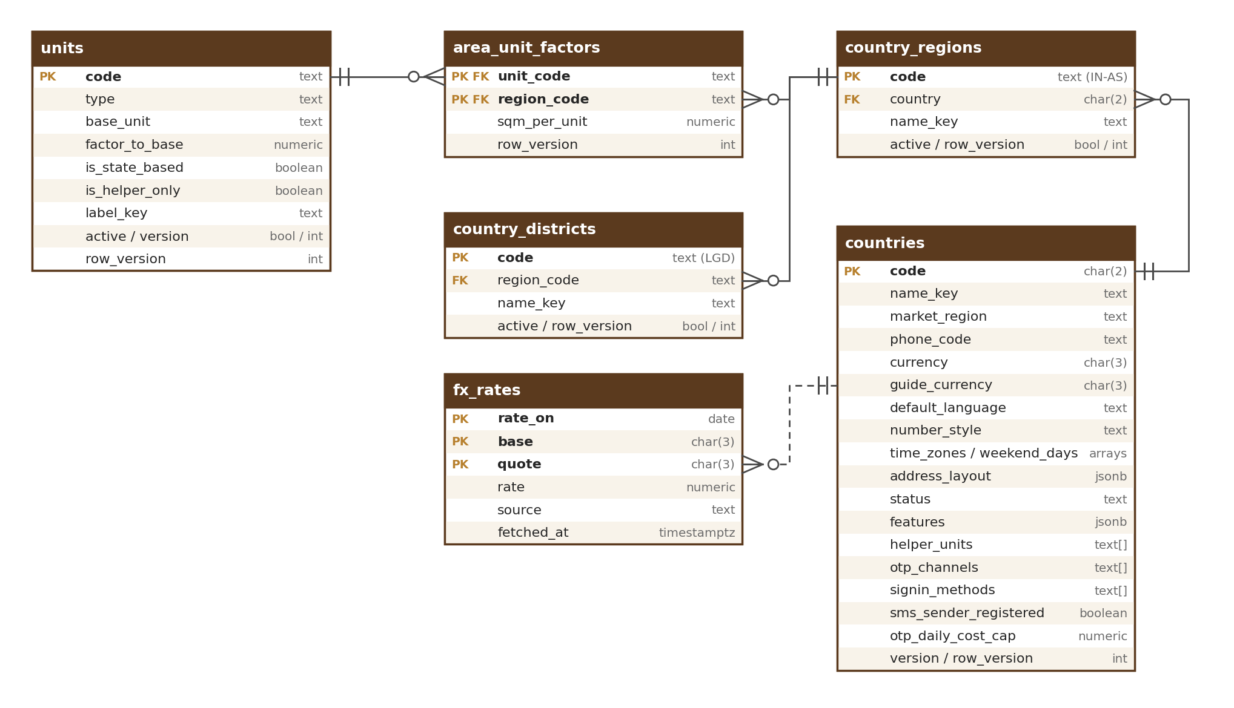
Figure 4 — Units, countries and exchange-rate tables

5.1 countries
Country table used by all modules (Admin-managed in the Country table screen, M01-6 Section 12.4).
Column | Type | Notes
code | char(2) PK | ISO 3166-1, e.g. IN, AE, SA, SG
name_key | text | Translation key
phone_code | text | e.g. +91, +971
currency / guide_currency | char(3) / char(3) | Listing currency (INR for IN, USD for others); guide currency e.g. AED
default_language / number_style | text / text | e.g. ar / international
time_zones / weekend_days | text[] / int[] | e.g. {Asia/Dubai} / {6,7}
address_layout | jsonb | Fields and order
market_region | text | Market area used to filter and group countries on staff screens and in reports: south_asia, gulf, other_middle_east, south_east_asia, east_asia, europe, americas, africa, oceania (e.g. gulf for AE and SA). Not a state or province — those are in country_regions (Section 5.2). An “other” change (M01-6 Section 12.1)
status | text | allowed, restricted, blocked
features | jsonb | Keys and values: opportunities (true / false, CTY-004), export_listings (true / false), selling_allowed (true / false), launch_status (open, invited_only, not_yet_open); e.g. {“opportunities”: false, “selling_allowed”: true, “launch_status”: “open”}
helper_units | text[] | e.g. {tola_w, tola_oil, mithqal}
otp_channels | text[] | OTP channel order, read by M02 (CTY-008); values sms, whatsapp, email, voice; e.g. {sms,voice,whatsapp,email} for IN (voice-call codes on request), {sms,email} for CN, {whatsapp,sms,email} for most others
signin_methods | text[] | Allowed sign-in methods: password, google, apple, passkey; e.g. CN without google
sms_sender_registered | boolean | OudhTrade SMS sender name registered in this country (e.g. Saudi Arabia and UAE before R2); if false, codes go by WhatsApp or email
otp_daily_cost_cap / otp_cost_currency | numeric(16,2) / char(3) | Daily OTP sending cost limit for the country (protects against SMS pumping); starting values in M01-2 CTY-008 (0 for countries not open for sign-up; IN 3,000 INR; each other open country 50 USD); the global cap for all countries is a setting (otp.global_daily_cost_cap); alert at 80 %
version | int | Published config version

5.2 country_regions
States and regions.
Column | Type | Notes
code | text PK | Full ISO 3166-2 code, e.g. IN-AS, IN-TR, AE-DU
country | char(2) FK → countries
name_key / active | text / boolean

5.3 country_districts
Districts (India at launch; other countries later if needed). Used by addresses, listings, profiles and lots.
Column | Type | Notes
code | text PK | India LGD district code (Local Government Directory)
region_code | text FK → country_regions | e.g. IN-AS
name_key / active | text / boolean | Retire, never delete (districts are split or renamed over time)

5.4 fx_rates
Daily exchange rates for guide prices.
Column | Type | Notes
rate_on / base / quote | date / char(3) / char(3) | PK; base INR or USD
rate | numeric(18,8)
source / fetched_at | text / timestamptz | Provider and time

6. Addresses
Page-address tables are shown in the diagram in Section 4. Reserved and banned names for business names and page addresses are in `reserved_names` (Section 13.4).

6.1 url_slugs
Current address of listings, stores, categories, guides. The one store of page addresses: the store web address is kept only here (M03 keeps no copy and reads it through UrlService, M01-3 Section 3).
Column | Type | Notes
id | uuid PK
entity_type / entity_id | text / uuid | Shared link (Section 11.1); UNIQUE (entity_type, entity_id) — one current address per record
slug | text | UNIQUE (entity_type, slug); e.g. assam-agarwood-chips-grade-a-10234; store: mrida-agro (3–40 characters, a–z, 0–9, hyphens; made from the business name, M01-2 URL-002)
changed_at | timestamptz | Set when UrlService makes a new address after profile.renamed (rename once per 90 days is an M03 rule)

6.2 url_redirects
Old addresses that redirect permanently.
Column | Type | Notes
old_path | text PK | Natural key (Section 1.1); internal path only — check: starts with a single “/”, no scheme or host
entity_type / entity_id | text / uuid
reserved_until | timestamptz | Old business names cannot be claimed by others for 12 months

7. Audit Log
The audit log is shown with events, jobs, retention and consent in the diagram in Section 9.

7.1 audit_log
Append-only; INSERT and SELECT only for the application.
Column | Type | Notes
id | bigint identity | PK (id, occurred_at) — partitioned tables include the partition key in the primary key
occurred_at | timestamptz | Partition key (month)
actor_type / actor_id / actor_role | text / uuid / text | user, staff, agent, system, ai
action | text | e.g. listing.approve, account.ban, config.publish, document.view, file.location_view (with the reason), legal_hold.release, job.discard
target_type / target_id | text / uuid
reason | text
before / after | jsonb | Masked personal data
ip / user_agent | inet / text
geo_city / geo_country | text / char(2) | Sign-in records only: city and country looked up once from the IP address when the record is written (no exact location); shown in Account activity
request_id | text
hash / prev_hash | bytea | Tamper-evident chain; empty when written, filled in id order by the sealing job (M01-3 Section 6)

Indexes: (target_type, target_id, occurred_at), (actor_id, occurred_at), (action, occurred_at), and a partial index on unsealed records (hash is null). Partitioned by month; each month is one hash chain, sealed when the month closes. Nightly copy to S3 with Object Lock (7 years).

8. Configuration, Switches and Rate Limits
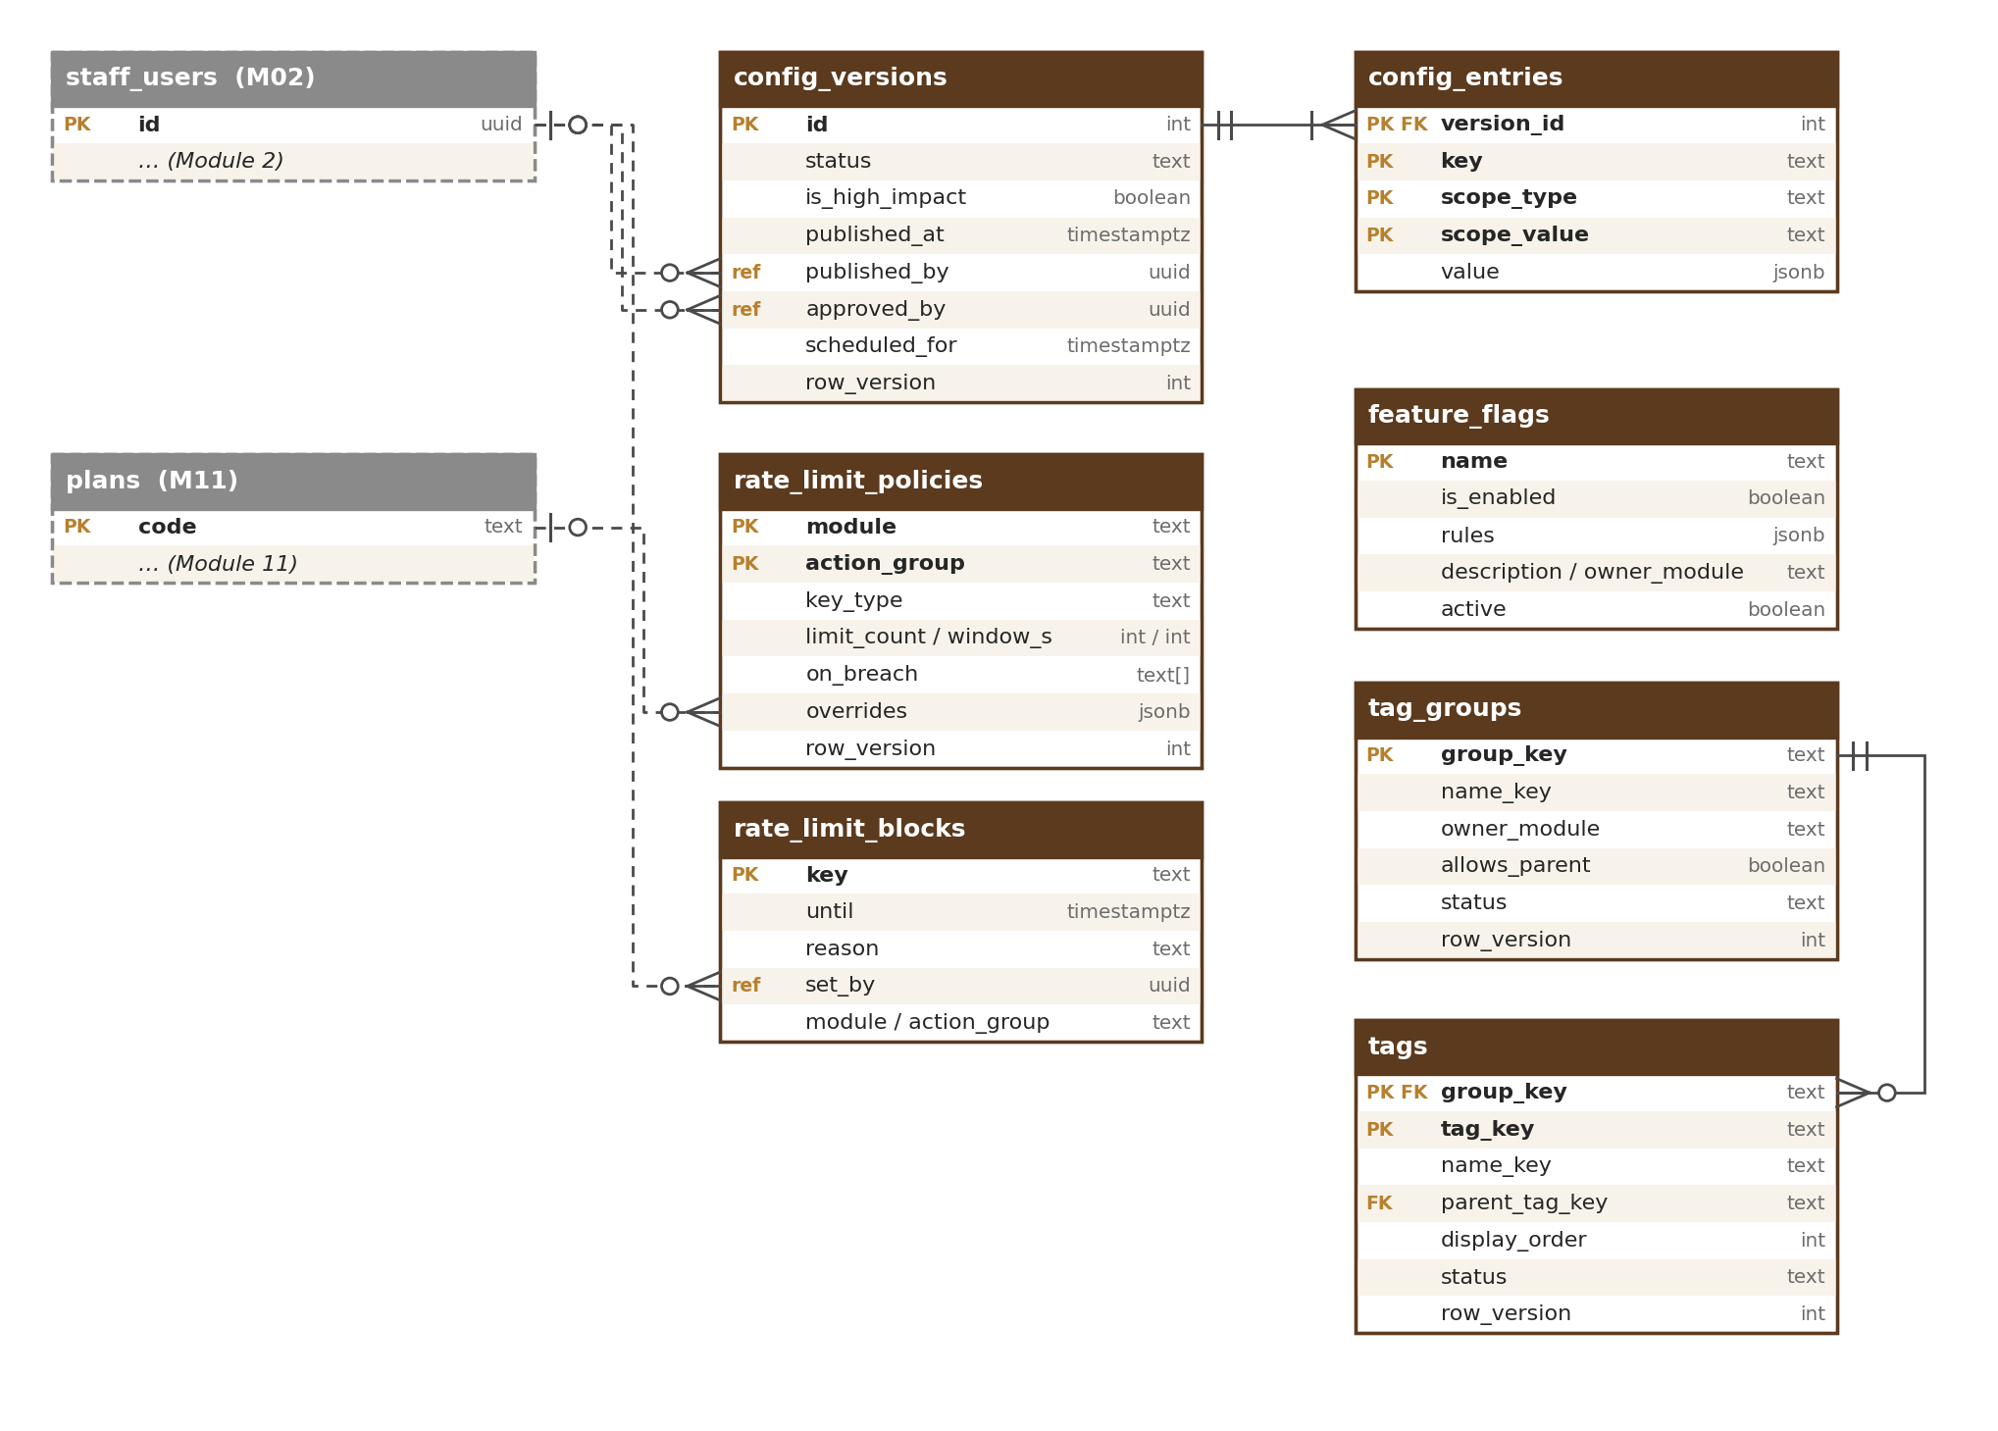
Figure 5 — Settings, feature-switch, rate-limit and simple-list tables

8.1 config_versions / config_entries
Versioned settings, prepared and approved in the Configuration Console (M16) with the common settings pattern (M01-6 Section 12.1) and published only through ConfigService.publish (M01-2 CFG-006).
Column | Type | Notes
config_versions.id / status | int / text | draft, waiting, approved, rejected, scheduled, published, cancelled, rolled_back. Allowed moves (check): draft → waiting → approved or rejected; approved → published, or approved → scheduled → published or cancelled; published → rolled_back when a rollback version replaces it. Same statuses as M01-6 Section 12.1
config_versions.is_high_impact | boolean | True when the version changes any high-impact setting in the list of M01-6 Section 12.1 (e.g. trust and ranking weights, prices, limits, permissions, compliance rules, legal texts, production feature switches, rate limits, AI budgets, Country table features); set by ConfigService from the setting’s level in the settings register (M01-2 Section 18), never by the editor
config_versions.submitted_by / submitted_at / submit_reason | uuid / timestamptz / text | Set when the draft is sent for approval (reason required)
config_versions.approved_by / approved_at | uuid / timestamptz | approved_by must differ from created_by for every version (check constraint): a second person always approves. When is_high_impact is true the approver must be a Super Admin (checked by ConfigService, M01-6 Section 12.1)
config_versions.approve_reason | text | Required with approval
config_versions.rejected_by / rejected_at / reject_reason | uuid / timestamptz / text | Set on rejection (reason required); the draft goes back to the editor
config_versions.scheduled_for | timestamptz | Publish time of a scheduled version; a scheduler job publishes it
config_versions.cancelled_by / cancelled_at / cancel_reason | uuid / timestamptz / text | Set when a scheduled version is cancelled (reason required)
config_versions.published_at / published_by | timestamptz / uuid | Set by ConfigService.publish; emits config.published
config_versions.rollback_of / rollback_reason | int / text | A rollback is a new draft that copies the values of version rollback_of (reason required) and needs approval; when it is published, the version it replaces gets status rolled_back
config_versions.is_emergency / reviewed_by / reviewed_at | boolean / uuid / timestamptz | Emergency path (M01-2 CFG-010): published at once without approval; the emergency reason is kept in submit_reason; a second Super Admin reviews within 24 hours on the Changes screen (M16-AD-01)
config_entries.version_id / key / value | int / text / jsonb | e.g. files.photo.max_mb = 15. Reasons for retiring a reserved name or a simple-list item are kept on the version (submit_reason) and in the audit log, not on the item
config_entries.scope_type / scope_value | text / text | global, country, category, plan, role, account_list; most specific wins: account list → role → plan → category → country → global (CFG-005)

8.2 feature_flags
Release switches.
Column | Type | Notes
name | text PK | e.g. r2.messaging; new switches are added only with code releases (by a developer)
description / owner_module | text / text | One line shown on the Feature switches screen; module whose code reads the switch
active | boolean | False when retired on the screen (reason, approval); a retired switch is no longer read
is_enabled / rules | boolean / jsonb | Value in this environment (each environment has its own console; switches move by export / import). Targets and overrides: release, environment, role, plan, category, country, account list (same list as M01-6 Section 12.3)

8.3 rate_limit_policies
Limits registered by each module (counters live in Redis).
Column | Type | Notes
module / action_group | text / text | PK, e.g. M01 / photo_upload
key_type | text | ip, device, account, plan, api_key, staff_user, crawler (signed-in users always account; crawler = verified by reverse DNS, M01-3 Section 10)
limit_count / window_s | int / int | e.g. 100 / 3600
on_breach | text[] | Ordered steps: wait, challenge, slow_down, ignore, block, security_event (e.g. {wait, challenge}); block lasts rate_limit.block_minutes
overrides | jsonb | By plan, role, country

8.4 rate_limit_blocks
Temporary and staff-set blocks.
Column | Type | Notes
key | text PK | e.g. ip:203.0.113.5
until / reason | timestamptz / text | Null until = permanent (staff only)
set_by | uuid | System or staff user
module / action_group | text / text | Policy that caused the block (null for staff-set permanent blocks); used for the 24-hour count on the Rate limits screen

8.5 tag_groups
Simple lists: one row per list (M01-2 CFG-011). A group is added only with the design of the module whose forms use it (by a database migration, because code reads the list by its key); staff can rename it but not add or remove it. Managed in the Simple lists screen (M01-6 Section 12.15) with the common settings pattern.
Column | Type | Notes
group_key | text PK | Natural key (Section 1.1): site_type, link_platform, capacity_unit, service_technique (the groups at launch, M01-2 CFG-011); a–z and underscore
name_key | text | Translation key of the group name, e.g. lists.site_type
owner_module | text | Module whose forms use the list, e.g. M03
allows_parent | boolean | True when items may sit under a parent item (one level); at launch only service_technique
status | text | active, retired (check); retire, never delete. A group is retired only with the module that uses it (database migration), never on a screen

8.6 tags
The items of each simple list. Other modules store the item key (for example M03 sites.site_type) and read names and order through the SimpleLists interface (M01-3 Section 3).
Column | Type | Notes
group_key | text FK → tag_groups | PK (group_key, tag_key)
tag_key | text | Stable item key stored by other modules, e.g. farm, distillery; a–z, 0–9 and underscore; never changed or reused, even after the item is retired
name_key | text | Translation key of the item name (up to 60 characters in each language); renaming changes the translation text, never the key
parent_tag_key | text, null | Parent item in the same group: FK (group_key, parent_tag_key) → tags; allowed only when tag_groups.allows_parent is true; one level only (a parent has no parent) (check in the service)
display_order | int | Order in lists and pickers; UNIQUE (group_key, parent_tag_key, display_order)
status | text | active, retired (check). A retired item is no longer offered; records that already use it keep it and still show its name. A parent with active items cannot be retired

9. Events and Jobs
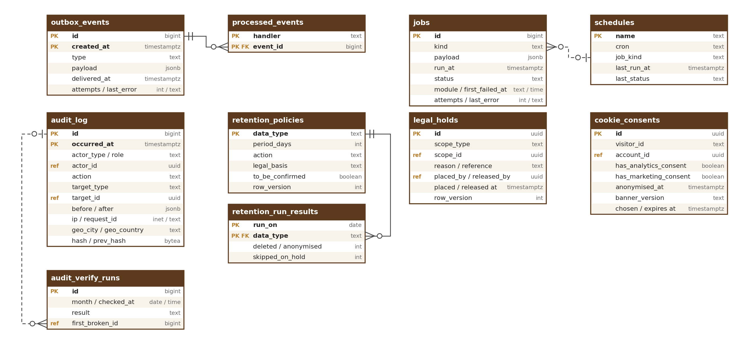
Figure 6 — Events, jobs, audit log, retention and consent tables

9.1 outbox_events
Events written with the business change.
Column | Type | Notes
id | bigint identity | PK (id, created_at)
type / payload | text / jsonb | e.g. file.ready; names from the event catalogue (HLD Appendix B)
created_at / delivered_at | timestamptz | delivered_at null until relayed
attempts / last_error | int / text

outbox_events is partitioned by month on created_at; delivered months are dropped after 30 days (configurable). processed_events rows older than 30 days are deleted by the same clean-up.

9.2 processed_events
Idempotency per handler.
Column | Type | Notes
handler / event_id | text / bigint | PK (handler, event_id)

9.3 jobs / schedules
Background work.
Column | Type | Notes
jobs.id / kind / payload | bigint / text / jsonb | Payload holds IDs only (e.g. file or account ID), never names, phone numbers or email addresses
jobs.module / first_failed_at | text / timestamptz | Owner module of the job kind; time of the first failure (for the failed jobs screen)
jobs.run_at / status / attempts / last_error | timestamptz / text / int / text | queued, running, done, dead (dead-letter), discarded (by staff with a reason kept in the audit log; failed jobs screen, M01-6 Section 12.11). “Retrying” on the screen = queued with attempts above 0. last_error = short error code and request ID only; personal data is removed before it is saved
schedules.name / cron / job_kind / last_run_at / last_status | text / text / text / timestamptz / text | e.g. retention.run 02:00 IST creates a retention job

9.4 audit_verify_runs
Result of each audit.verify run (M01-3 Section 6); read by the audit log viewer (M01-6 Section 12.9).
Column | Type | Notes
id | bigint identity | PK
month / checked_at | date / timestamptz | Month checked and when
result | text | intact, break_found
first_broken_id | bigint, null | First audit_log record where the chain breaks

10. Retention, Legal Hold and Consent

10.1 retention_policies
Retention per data type. Managed in the retention policies screen (M01-6 Section 12.12) or moved from staging by export / import; changes are high impact.
Column | Type | Notes
data_type | text PK | e.g. unattached_upload, closed_account, security_log
period_days | int | [TBC: final with counsel]
legal_min_days | int | Shortest period the law allows; period_days can never be lower (check)
action | text | delete or anonymise
legal_basis | text | Why kept this long
to_be_confirmed | boolean | True while counsel has not confirmed the period; the screen shows “To be confirmed with counsel”

10.2 legal_holds
Stops deletion for linked data. Placed and released in the legal hold screen (M01-6 Section 12.10) or automatically by takedowns (M12).
Column | Type | Notes
id | uuid PK
scope_type / scope_id | text / uuid | account, profile, listing, thread, trade, file, legal_order (the one list, Section 11.1; also used by M01-6 Section 12.10)
reason / reference | text | Legal order or dispute reference
placed_by / placed_at / released_by / released_at | uuid / timestamptz | All audited; placed_by null = system (takedown)
release_reason | text | Required when released_at is set (check)

Hold count per data type. A hold on an account or profile covers every data type of that account (its files, messages, trades and the closed-account record); a hold on a listing, thread, trade or file covers that record and its files; a legal_order hold covers the records named in the order. The retention policies screen counts, per data type, the active holds whose scope includes records of that type.

10.3 cookie_consents
Proof of cookie choices.
Column | Type | Notes
id | uuid PK
visitor_id / account_id | text / uuid | visitor_id: a random first-party ID (a UUID made for the consent cookie; no personal data, not linked to a device or IP); account_id if signed in
has_analytics_consent / has_marketing_consent | boolean
banner_version / chosen_at / expires_at | text / timestamptz | 12 months

10.4 retention_run_results
Result of each daily retention run per data type (shown as “last daily run” on the retention policies screen).
Column | Type | Notes
run_on / data_type | date / text FK → retention_policies | PK (run_on, data_type)
deleted / anonymised / skipped_on_hold | int / int / int | Items deleted, anonymised, and kept because of a legal hold

11. Links to Other Modules
Module 1 tables hold only the IDs of records that belong to other modules. There are no database foreign keys across modules, so each module can change (or later be split out) without breaking Module 1. The owning module keeps the link correct through its interface and events — for example, when an account is closed (Module 2), Module 1 anonymises that account’s preferences and consents.
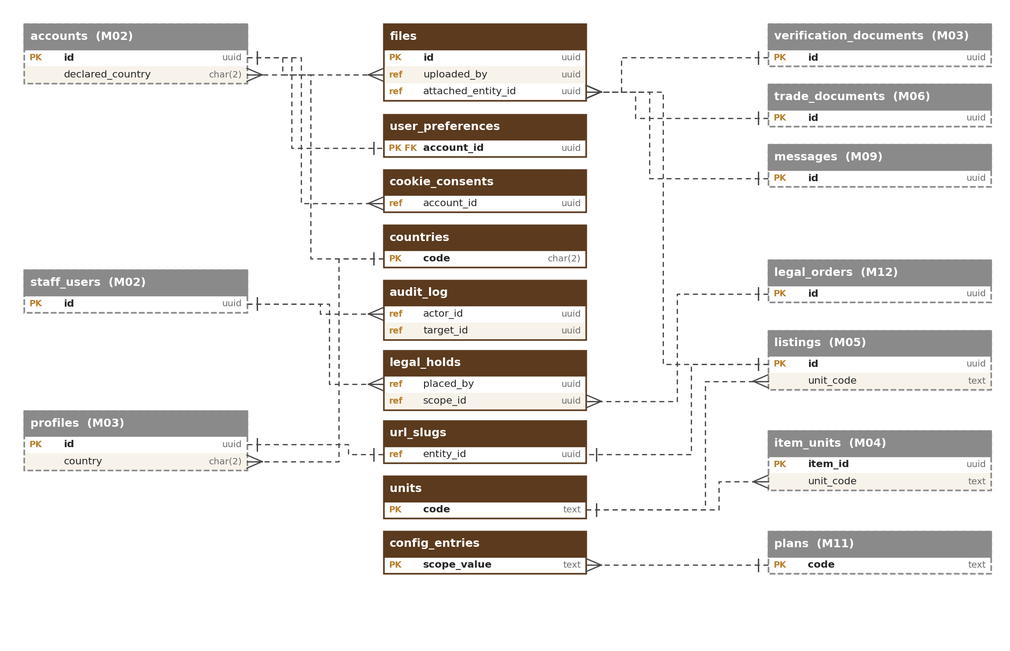
Figure 7 — Links from Module 1 tables to other modules
Module 1 column | Points to | Owner
files.uploaded_by (owner_type = account), user_preferences.account_id, cookie_consents.account_id, ai_requests.account_id, idempotency_keys.caller_id | accounts | M02
files.uploaded_by (owner_type = staff), audit_log.actor_id, legal_holds.placed_by, config_versions.published_by / approved_by, video_assets.reviewed_by, image_blocklist.blocked_by, rate_limit_blocks.set_by | staff_users (or accounts for user actions) | M02
files.attached_entity_id | verification_documents, trade_documents, listings, messages, profiles, pages (by attached_entity_type) | M03, M06, M05, M09, M03, M17
url_slugs.entity_id | listings, profiles (stores), taxonomy_nodes (categories), pages (guides) | M05, M03, M04, M17
legal_holds.scope_id | legal_orders and the held records (by scope_type): accounts, profiles, listings, threads, trades, files | M12, M02, M03, M05, M09, M10, M01
audit_log.target_id | Any record acted on (by target_type) | All modules
units.code (used by) | item_units.unit_code, listings.unit_code | M04, M05
countries.code (used by) | accounts.declared_country, accounts.phone_country, accounts.signup_ip_country, profiles.country | M02, M03
country_regions.code / country_districts.code (used by) | region_code and district_code of profiles, listings, lots | M03, M05, M06
config_entries.scope_value (plan) | plans.code | M11
tags (group_key, tag_key) (used by) | sites.site_type; profile link platform; capability capacity unit and service technique | M03

Table names of other modules are planned names; they are confirmed in each module’s database design. Links of the Section 13 tables are shown in the diagram in Section 13.

11.1 Shared link columns
Four Module 1 tables use a shared link (a “type” column plus an “ID” column): `files.attached_entity_type / attached_entity_id`, `url_slugs.entity_type / entity_id`, `audit_log.target_type / target_id` and `legal_holds.scope_type / scope_id`. They follow the shared-link rules of the Master Database Design (Section 6.1). Module 1 specifics:
- Allowed types (named after the target table, database check): files — listing, verification_document, trade_document, message, profile, page; addresses — listing, profile, taxonomy_node, page; audit log targets — account, staff_user, profile, listing, requirement, thread, message, quotation, trade, review, verification_case, moderation_case, legal_order, subscription, invoice, file, config_version, legal_hold (new types added with the owning module’s design); legal holds — account, profile, listing, thread, trade, file, legal_order (the one list; M01-6 Section 12.10 uses it).
- Index: each (type, ID) pair is indexed: files (attached_entity_type, attached_entity_id), url_slugs (entity_type, entity_id) unique, audit_log (target_type, target_id, occurred_at), legal_holds (scope_type, scope_id).
- Clean-up: on `listing.removed`, `document.deleted`, `message.deleted` and `account.closed` Module 1 detaches files and redirects or retires the address. Audit targets are never removed (the audit log keeps the ID even after the record is gone); a legal hold whose record is gone stays until staff release it.
- Nightly check: schedule `refs.orphan_check` (M01-3) reports links of all four tables that point to missing records; for the audit log it only reports, never changes records.

12. Rules
Module 1 follows the standards of the Master Database Design (naming, IDs and UUID version 7, standard columns, data types, schema as code, safe migrations, database users). Module 1 specifics:
- The audit log, outbox, jobs and ai_requests use bigint identity keys; audit_log, outbox_events and ai_requests are partitioned by month and include the time column in the primary key.
- Reference data (units, translations, countries, config versions, reserved names, holidays, simple lists) is retired (active = false, or status retired for simple lists), never deleted.
- Foreign keys are enforced by the database inside Module 1; links to other modules are ID references (ref) without database constraints.
- Personal-data columns (files.location_private, user_preferences, cookie_consents, audit_log actor and IP, rate_limit_blocks key, ai_requests.account_id, idempotency_keys stored responses) are listed in the master data map and covered by retention policies.

13. AI Gateway, API Safety, Names and Calendar
Five tables support the AI gateway (M01-3 Section 14), idempotency keys (API-005), reserved names (URL-008) and the holiday calendar (LOC-012). Standard columns (Section 1.1) apply as usual.
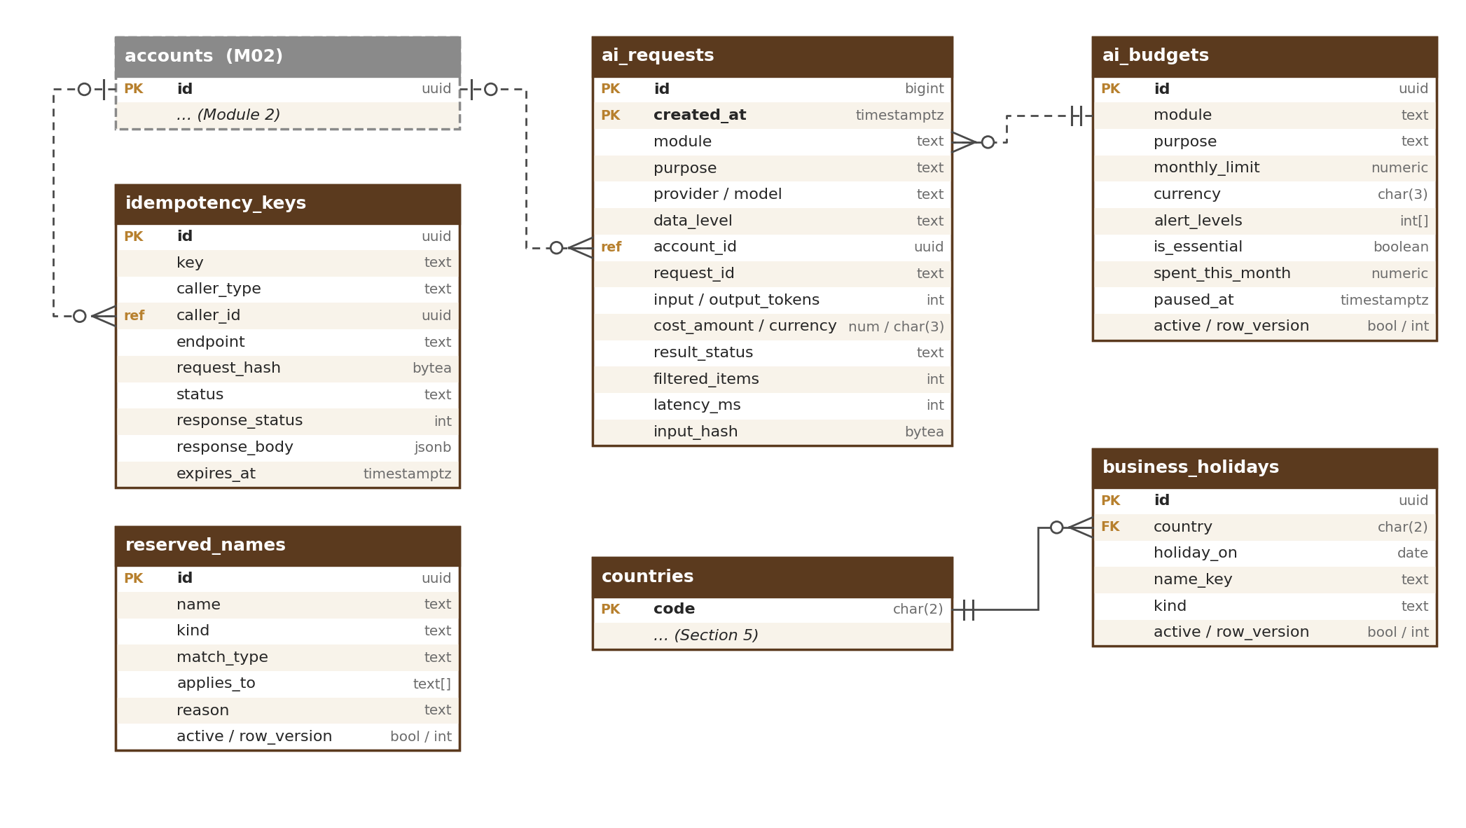
Figure 8 — AI gateway, API safety, names and calendar tables

13.1 ai_requests
One row per AI call through the gateway (AIG-003). Append-only; partitioned by month on created_at.
Column | Type | Notes
id | bigint identity | PK (id, created_at)
created_at | timestamptz | Time of the call; partition key
module / purpose | text / text | e.g. M07 / search_embedding
provider / model | text / text | Provider and model version used
data_level | text | public, internal, confidential (check); Restricted data is never sent
account_id | uuid (ref) | Account whose personal data was sent, if any (processing log); otherwise null
request_id | text | Links to the API request and logs
input_tokens / output_tokens | int / int
cost_amount / cost_currency | numeric(16,6) / char(3) | Six decimals because one call costs a fraction of a cent; totals are rounded to 2 decimals
result_status | text | ok, blocked_by_filter, over_budget, provider_error, timeout
filtered_items / latency_ms | int / int | Items removed by the data filter; response time
input_hash | bytea | SHA-256 of what was sent; prompt and output text are not stored

13.2 ai_budgets
Monthly AI cost limits per module and purpose, with alert levels (AIG-004).
Column | Type | Notes
id | uuid PK
module / purpose | text / text | UNIQUE (module, purpose); purpose “*” = all purposes of the module
monthly_limit / currency | numeric(16,6) / char(3) | Amounts in M01-2 AIG-004 (total from the tech lead’s estimate; moderation 40 %)
alert_levels | int[] | Per cent; default {80, 100}
is_essential | boolean | Essential purposes keep running at 100 % (alert only); others pause
spent_this_month | numeric(16,6) | Reconciled hourly from ai_requests (same precision as ai_requests.cost_amount)
paused_at | timestamptz | Set when a non-essential purpose pauses; cleared at month start or when the limit is raised
active | boolean

13.3 idempotency_keys
Makes retried writes safe (API-005): the first response is stored for 24 hours and returned for repeats.
Column | Type | Notes
id | uuid PK
key | text | Value of the Idempotency-Key header (a UUID made by the client)
caller_type / caller_id | text / uuid (ref) | account, staff_user, api_key or visitor (caller_id = cookie_consents.visitor_id; only on POST /v1/consents); UNIQUE (caller_type, caller_id, endpoint, key)
endpoint | text | Method and path pattern, e.g. POST /v1/files
request_hash | bytea | SHA-256 of the request body; a different body with the same key is refused
status | text | in_progress, completed
response_status / response_body | int / jsonb | Stored first response
expires_at | timestamptz | created_at + 24 hours; expired rows deleted hourly

13.4 reserved_names
Reserved, banned and protected brand names for business names and page addresses (URL-008). Managed in the reserved-names screen (M01-6 Section 12.5) or moved from staging by export / import, with the same approval.
Column | Type | Notes
id | uuid PK
name | text | Normalised form (lower case, transliterated, look-alike characters folded)
kind | text | reserved (e.g. admin, help, oudhtrade), banned, protected_brand; a name is on the list once, with one kind: UNIQUE (name)
match_type | text | exact or contains (check: contains only for kind protected_brand with 5 or more characters; reserved and banned words are always exact)
applies_to | text[] | business_name, page_address
reason | text | e.g. brand owner, legal order reference
active | boolean | Retire, never delete

13.5 business_holidays
Holiday calendar used by the IST business-hours calculator (LOC-012). Managed in the holiday calendar screen (M01-6 Section 12.6) or moved from staging by export / import, with the same approval.
Column | Type | Notes
id | uuid PK
country | char(2) FK → countries | IN at launch
holiday_on | date | UNIQUE (country, holiday_on)
name_key | text | Translation key made by the server from the English name staff type (e.g. Diwali → holiday.diwali); the English text is stored in translations
kind | text | national or company
active | boolean | Retire, never delete

14. Indexes and Volumes
Main indexes and a year-1 row estimate for every Module 1 table. Every link column is indexed (Master Database Design, Section 9.3). Figures are estimates for design; load tests before R2 confirm them.
Table | Main indexes (besides the primary key) | Rows, year 1
files | (owner_type, uploaded_by, status); (attached_entity_type, attached_entity_id); (status, expires_at); fp_band_1, fp_band_2, fp_band_3, fp_band_4 (each, photos only) | ≈ 1.2 million
file_variants | (file_id) | ≈ 3.6 million
video_assets | (review_status) | ≈ 20,000
image_blocklist | fp_band_1 … fp_band_4 (each) | < 10,000
units · area_unit_factors | (type, active) · (region_code) | < 50 · < 200
translations | (locale, status) | ≈ 20,000
user_preferences | — | ≈ 50,000
trade_terms | (group_id); (lower(term), locale) | < 5,000
countries · country_regions · country_districts | (status) · (country) · (region_code) | ≈ 250 · ≈ 5,000 · ≈ 800
fx_rates | (quote, rate_on) | ≈ 4,000
url_slugs | UNIQUE (entity_type, entity_id); UNIQUE (entity_type, slug) | ≈ 170,000
url_redirects | (entity_type, entity_id); (reserved_until) | ≈ 50,000
audit_log | (target_type, target_id, occurred_at); (actor_id, occurred_at); (action, occurred_at); partial (hash is null) | ≈ 5 million (kept 7 years)
config_versions · config_entries | (status, scheduled_for) · (key, scope_type, scope_value) | < 1,000 · ≈ 50,000
feature_flags · rate_limit_policies | — | < 200 each
tag_groups · tags | — · (group_key, status, display_order); (group_key, parent_tag_key) | < 20 · < 500
rate_limit_blocks | (until); (module, action_group, created_at) | < 50,000 (short-lived)
outbox_events | partial (delivered_at is null, created_at) | ≈ 10 million a year (dropped after 30 days)
processed_events | — | Cleaned after 30 days
jobs · schedules | (status, run_at); (module, status) · — | ≈ 5 million (done jobs cleaned after 30 days) · < 100
audit_verify_runs | (month) | ≈ 400 a year
retention_policies · legal_holds | — · (scope_type, scope_id); (released_at) | < 100 · < 500
retention_run_results | (data_type, run_on) | ≈ 10,000 a year
cookie_consents | (visitor_id); (account_id) | ≈ 500,000
ai_requests | (module, purpose, created_at); (account_id) | ≈ 1–3 million (depends on the AI features switched on)
ai_budgets | UNIQUE (module, purpose) | < 100
idempotency_keys | UNIQUE (caller_type, caller_id, endpoint, key); (expires_at) | ≈ 50,000 live (24 hours)
reserved_names | UNIQUE (name); (kind, active) | ≈ 5,000
business_holidays | UNIQUE (country, holiday_on) | ≈ 20 a year

14.1 Photo fingerprint search
- Each photo stores its 64-bit fingerprint and the same value cut into four 16-bit bands (fp_band_1 … fp_band_4), each with its own index.
- To find copies, the database first looks for candidates that share at least one band with the new photo (four fast index look-ups), then checks each candidate by Hamming distance (number of differing bits) against the configurable threshold.
- Two fingerprints that differ in 3 bits or fewer always share at least one band, so no match within that distance is missed. The threshold starts at 3 bits and is tuned on real photos before R1 (setting files.copy_match.max_distance). Above 3 bits the band look-up can miss some matches, and some heavily edited copies (strong crops, mirrored or recoloured photos) may be missed at any threshold. The block list (image_blocklist) is searched the same way.

